**BILAR EMERGENCY RESPONSE APPLICATION USING DYNAMIC CLUSTERING PROTOCOL**

A Thesis

Presented to the Faculty of the College

of Technology and Allied Sciences

BOHOL ISLAND STATE UNIVERSITY

Zamora, Bilar, Bohol

In Partial Fulfillment

of the Requirement for the Degree in Bachelor of Science in Computer Science

Armando C. Jumawid Jr.

Ronelyn G. Perocho

Mark Henry Perez

August 2024

**ABSTRACT**

Nowadays, there are numerous catastrophic events, which affects a large number of people in the world including crises, fires, floods, road accidents, earthquakes, and terrorist attacks. The majority of public people use mobile and internet all day long. Emergency response systems play a crucial role in ensuring rapid and efficient assistance during critical situations. This research paper presents the development and evaluation of the application called “Bilar Emergency Response Application (BERA), using Dynamic Clustering Protocol” to enhance the effectiveness of emergency response operations. The proposed system leverages the ubiquity of smartphones and their inherent capabilities to facilitate real-time communication, coordination, and resource allocation among responders and affected individuals. Through dynamic clustering, BERA optimizes the allocation of resources based on the evolving nature of emergencies, ensuring timely assistance to those in need.The effectiveness of the application is evaluated through simulations and real-world scenarios, demonstrating its potential to significantly improve emergency response outcomes. BERA represents a promising advancement in the field of emergency management, offering a scalable and adaptable solution to address the challenges of modern-day emergencies.

Keywords: Bilar Emergency Response Application (BERA), ubiquity of smartphones, real-time communication, dynamic clustering

**Chapter 1**

1

## THE PROBLEM AND ITS SCOPE

### **Rationale**

Emergencies are inherently unpredictable, occurring anywhere and anytime, necessitating rapid decision-making. This unpredictability can disrupt the usual chain of command, potentially leading to lapses in judgment and significant losses. The general public is not exempt from a various security threats, both internal and external. These threats can cause physical harm and even death. Among the causes of death are heart disease, traffic accidents, and death caused by criminal activities.

Building upon the insights gained from the global response to the COVID-19 pandemic, as highlighted by Erkhembayar et al. (2020), our research aims to further enhance emergency response mechanisms. The proactive measures taken by countries, such as Mongolia, underscore the importance of efficient emergency response frameworks, facilitated by legal structures like the State Emergency Committee and the Disaster Protection Law. Despite these frameworks, challenges persist in promptly reporting emergencies, especially in remote areas where victims may encounter difficulties in using traditional communication methods like phone calls or SMS.

Drawing from established research, such as the work of Khalemsky & Schwartz (2017) & McNab et al. (2009), which highlight the transformative impact of mobile emergency response applications, our study seeks to expand upon these insights. Khalemsky & Schwartz, (2017) demonstrated the substantial reduction in response times achieved through mobile emergency applications, resulting in faster medical assistance and improved patient outcomes. McNab et al. (2009) provided valuable insights into the design principles of these applications, emphasizing the importance of achieving optimal performance. In the context of our research, these studies underscore the potential of advanced technology in enhancing emergency services and response effectiveness

To address the challenge of improving emergency response times in remote areas, the implementation of this research can provide a centralized platform for rapid emergency calls, precise GPS location information, direct communication with local emergency services, and emergency requestor identification. This comprehensive approach enhances the region's emergency response capabilities and better protects its residents.

As technology advances, it provides alternatives, and solutions begin to emerge. One suggested technology is a personal emergency notification mobile application (Hong et al., 2017). Technologies like BERA are crucial in enhancing response times and effectiveness. Through this application, the public can effortlessly dispatch emergency messages to family, friends, or relevant institutions. The application aids in facilitating evacuation by providing information about the sender's location and the nature of the threat encountered. This application is anticipated to make a practical contribution to the community by offering a swift communication method during crucial situations. It is also expected to support existing emergency assistance services by providing valuable assistance to authorized agencies.

### **Literature Background**

According to Republic Act No. 10121, also known as the "Philippine Disaster Risk Reduction and Management Act of 2010," this legislation provides a robust legal and policy framework for disaster risk reduction and management in the Philippines. By adhering to the provisions of this act, the application aims to contribute to enhancing the country's disaster preparedness, response, and recovery efforts. It underscores the commitment to promoting resilience and reducing the adverse impact of disasters on communities and individuals, as envisioned in RA 10121.

Republic Act No. 10121, enacted on May 27, 2010, serves as the legal foundation for the Philippine Disaster Risk Reduction and Management System. The law outlines the country's commitment to addressing vulnerabilities, enhancing institutional capacities, and building community resilience to disasters and climate change impacts. It emphasizes a holistic and proactive approach, incorporating international principles, and aims to integrate disaster risk reduction into various aspects of development, governance, and peace processes. The Act underscores the importance of gender-responsive, community-centered, and environmentally sustainable disaster risk reduction and management practices.

The Senior Technology Exploration, Learning, and Acceptance (STELA) model, as proposed by Tsai et al. (2019) in their longitudinal randomized controlled trial published in Educational Gerontology (45(12), 728-743), aims to investigate the intricate dynamics of technology exploration and learning. As individuals age, the process of adopting new technologies becomes increasingly complex.

As we enter the era of globalization, technology usage optimization should be put into practice and continue to grow in the area of personal and public security. This is important because as we advance in the globalization timeline, the risks to our security in every area of our lives are at risk.

The Women's Design Service in London, UK, developed the "Making Safer Places" procedure in Bristol, Wolverhampton, London, and Manchester. The procedure uses a tool called the "fear-o-meter" to investigate the things that make women afraid (Whitzman, Legacy et al. 2013). The women conducted a survey of their domestic neighborhood, estate, and playground using highly participatory equipment in order to determine the aspects of the physical environment that need to be improved. For instance, rerouting roads, establishing fences, and identifying and moving vegetation.

Both personal and public safety are issues that could be addressed by further improving the current environment in our society. We cannot dispute that neglected infrastructure exists in both our urban and rural areas, and that these areas need to be improved in order to stop serving as magnets for criminal activity.

In Steurer's (2018) study on worldwide crime, homicide rates and burglary/housebreaking rates were analyzed across 198 countries, utilizing data from Knoema. The examination unveiled a diverse range of crime rates, prompting the application of logarithmic transformation to attain a more normalized distribution.

As they say, "Prevention is better than cure," so law enforcement should seriously think about using technology to deter crime. Given that crime prevention could be improved in an efficient and effective manner, this could help law enforcement officials in their duties.

Four stages of disaster management are typically recognized in the field: mitigation, preparedness, response, and recovery (Zlatanova et al., 1998). Preparation is mostly focused on routine planning within the emergency services and law enforcement (e.g., for emergency situations such as police, ambulance, fire). Every phase is interrelated and vital, but from the perspective of saving lives, the response and recovery phases are frequently regarded as the most important.

As a result, it is imperative that law enforcement respond to calls from crime victims as soon as they are received. In order to lessen the aftereffects of a crime towards the victim or victims who made the call, moments like these should be handled carefully and quickly.

The idea of an event timeline is one that is frequently applied in emergency response. This outlines the incidents, emergency calls, reactions, and other actions in chronological order. that take place throughout an event Sene (2008). Timelines are useful for post-event response assessment and can be made instantly available to help other responders comprehend the circumstances.

Emergency response systems play a crucial role in mitigating the impact of disasters and crises, ranging from natural calamities to human-made incidents. Efficient coordination and resource allocation are imperative for effective emergency management. Dynamic clustering algorithms offer promising solutions for optimizing resource allocation and response coordination in emergency situations. By leveraging real-time data and adaptive algorithms, emergency response systems can improve their effectiveness and resilience in mitigating the impact of disasters and crises. Continued research and innovation are essential for advancing the application of dynamic clustering in emergency response and enhancing overall disaster management capabilities.

Clustering algorithms serve as essential tools in data analysis, enabling the automatic grouping of similar data points and unveiling patterns within large datasets. By categorizing data into distinct clusters, these algorithms simplify the interpretation of complex information, aiding researchers and practitioners in extracting meaningful insights. Their versatility extends to various domains, contributing to market segmentation, image analysis, biological data interpretation, and more, making clustering algorithms indispensable for effective data exploration and decision-making.

According to Xu and Wunsch's influential research on clustering algorithms, cluster analysis emerges as a crucial tool for comprehending unlabeled data, with their exploration of hierarchical structures and group formation emphasizing specific goals while acknowledging ongoing efforts to address associated challenges (Xu & Wunsch, 2005). In another study by Xu, D., & Tian, Y. (April 2015), an overview of commonly used clustering algorithms is presented, introducing their basic ideas, specifying sources, and analyzing the advantages and disadvantages of 19 selected categories, aiming to offer readers a systematic and clear understanding of this important data analysis method. A study by Na, S., Xumin, L., & Yong, G. (April 2010) explores the significance of clustering analysis in data mining, emphasizing the direct impact of clustering algorithms on results. It specifically discusses the drawbacks of the standard k-means algorithm, proposing an enhanced version that optimizes efficiency by utilizing a simplified data structure to store information across iterations, ultimately improving both the speed and accuracy of clustering.

Regarding our law enforcement's emergency responses, there is one thing we can all agree upon. In an emergency, emergency response should always occur as quickly as possible to protect victims of crime from additional harm from the already-occurring crime.

The following articles provide valuable insights and resources for creating and enhancing emergency response systems and applications, offering essential guidance for developers seeking to improve disaster preparedness and response capabilities.

Designing Mobile Applications for Emergency Response: Citizens Acting as Human Sensors, the authors conducted an investigation of emergency notification (EN) mobile applications, aiming to analyze their characteristics and practical usefulness. They used the Design Science Research (DSR) approach and identified that while generic social applications are commonly used for large-scale crises, specific EN applications are more effective for small-scale events. They also found that users prefer multimedia features over text and forms in such applications, suggesting the potential for improved usability and adoption in emergency situations.

The review of emergency response in disasters: present and future perspectives study conducts a systematic analysis of 3,678 publications (1970–2019) from the Web of Science to investigate the emerging field of emergency response research in disasters. The analysis employs bibliometric and social network analysis methods, revealing key research topics such as emergency response, simulation, optimization, emergency medicine, and education. The paper also identifies four primary research themes and highlights two research hotspots ("optimization" and "demand"), providing valuable insights and directions for future research in the field of emergency response.

Disaster management and emerging technologies: a performance-based perspective paper employs a systematic literature review (SLR) and VOSviewer software to analyze the impact of emerging technologies (ETs) on disaster management (DM) processes. It highlights the complexity and varying terminology in the DM field, emphasizing the importance of clarifying phases and roles. The study identifies key ETs, such as simulation, robotics, IoT, and social media, and their associations with different DM phases, emphasizing the potential of simulation for preparedness, robotics and IoT for response, and social media for performance measurement, management, and accountability. Additionally, the paper suggests future research directions and practical implications for enhancing DM performance using ETs.

User-Centered Design enhances the research by providing a fundamental framework for developing an effective emergency response application, such as "BERA." Examination of technology-driven strategies in "BERA" seeks to reveal the profound impact of user-centered design principles on its overall effectiveness. This approach ensures the app is meticulously tailored to meet user needs, especially in high-stress emergency scenarios.

The integration of a clustering protocol algorithm within the "BERA" emergency response application plays a vital role in enhancing situational awareness and response prioritization. By systematically identifying incident clusters and directing resources in a data-driven manner, the application not only reduces response times but also contributes to overall user safety.

There are numerous related applications that are running in different organizations and institutions. Among these significant studies where:

Citizen – This App provides COVID contact tracing, real-time safety alerts, and 24/7 assistance at your fingertips. In the midst of the pandemic, it helps track potential COVID exposures and offers key features like free at-home testing, crime alerts, police activity updates, breaking news videos, and safety alerts for loved ones. Citizen app is a powerful tool for personal safety and COVID-19 awareness, puts vital information and resources in your hands, ensuring you stay informed and prepared in challenging times.

Emergency + – This national app utilizes the GPS built into smartphones to display users' location coordinates. In the event of an emergency, when users dial Triple Zero (000), this app enables them to convey their precise location to the emergency call-taker. Additionally, the app provides information on other national numbers such as Crime Stoppers, Health Direct, and the National Relay Service. Furthermore, it includes built-in accessibility features that audibly describe on-screen content, allowing callers to use the app even without visual interaction. Vision Australia conducted a review of the app to ensure compliance with accessibility requirements.

EchoSOS – EchoSOS was created to improve first contact and communication between people requesting help and the emergency services. EchoSOS is constantly being developed to face the challenges in rescue and health care and to improve communication and information exchange. EchoSOS was developed with the primary goal of enhancing the initial contact and communication between individuals seeking assistance and emergency services, and it continues to evolve to meet the ever-evolving challenges in rescue and healthcare, prioritizing the enhancement of communication and information exchange for more effective emergency responses.

SirenGPS – Dialing 911 from a mobile phone doesn't bring instant aid, because dispatchers need some location info to find you. SirenGPS (Android, iOS) puts them at the touch of one big red button. If your community subscribes to Siren 911, nearby first responders will receive your location and profile (emergency contacts, medical history, allergies and current medications, which you put into the app), improving your chance of being rescued in time.

## THE PROBLEM

### **Statement of the Problem**

This study aimed to design and develop an application called BERA for Bilar Search and Rescue Unit (BISARU) in BISU to improve communication, coordination, and response times during emergencies.

Specifically, it seeks to answer the following questions:

1. What are the current processes for receiving emergency calls and tracking the location of emergency during response operations?

2. What features were essential in the development of the BERA?

3. How to design the application with the modules?

1. Emergency Notification
2. User Authentication and Role Management
3. Location Tracking
4. Clustering Protocol
5. Reports
6. What is the level of application acceptability regarding the usability of the emergency response application, as perceived by the target users?

### **Objectives**

The main objective of the study is to design an application called Bilar Emergency Response Application (BERA).

Specifically,

1. To develop an Emergency Response Application for BISARU in Bilar, Bohol.
2. To test and evaluate the system using System Usability Survey.
3. To implement and deploy the application called BERA in Bilar Bohol.

### **Scope and Delimitation**

The proposed application focused on the following modules:

* **Emergency Notification –** This module's scope involves defining how emergency alerts are received, processed, and communicated within the application. It may include features for reporting different types of emergencies and the level of detail provided in alerts.
* **User Authentication and Role Management –** ensure secure access to the emergency response application, allowing users to register, log in, and recover passwords while maintaining security measures. Additionally, role management enables administrators to assign and modify user roles, ensuring that authorized individuals have appropriate access levels to perform their designated tasks within the application.
* **Location Tracking –** The scope of this module encompasses how the application tracks and displays the real-time location of emergency responders and individuals in distress. It may specify the technology used for location tracking and the level of accuracy required.
* **Clustering Protocol -** Integrating a clustering algorithm within the Emergency Response Coordination module optimizes resource allocation, enhances situational awareness, and streamlines response prioritization. By systematically identifying incident clusters and directing resources in a data-driven manner, the application not only reduces response times but also contributes to overall user safety during emergency scenarios.
* **Reports** **–** This module's scope includes the generation of reports and analytics related to response times, resource utilization, and overall system performance. It defines the types of reports and the key performance indicators to be tracked.

The study may predominantly pertain to Bilar Bohol, Philippines, and might not be directly applicable to regions with markedly distinct geographic attributes, infrastructure, or emergency response requirements. The system will exclusively be available on platforms like Android mobile devices and web browsers on desktop and laptop computers, with provisions for offline functionality in areas with restricted connectivity. The application will solely perform functions such as real-time incident reporting, location tracking, resource allocation, communication, mapping, user management, reporting, notification, and data storage, all aimed at augmenting emergency response capabilities within the confines of the municipality of Bilar.

### **Significance of the Study**

This project is to bring positive implications to the society in the issue of requesting for help during critical or emergency situations. In particular, the following entities may benefit from this study:

* Affected Individuals and Communities
* Researchers
* Future Researcher

## RESEARCH METHODOLOGY

### **Conceptual Diagram of the Study**

Figure 1 below represents the conceptual diagram of the study that represents the principle of input-process-output. Inputs are the incident reports of emergency requestor collected by the administrator. The process involves incident reporting, location tracking, user authentication, clustering and resource allocation. The output includes reports detailing incidents and response times.



Emergency Responder

Output

(Reports)

Emergency Requestor

Firebase Server

Administrator

Location Tracking

Response

Clustering Algorithm

Incident Reporting

User Authentication

Figure 1. Conceptual Diagram of the BERA Application

### **Block Diagram of the Study**

Figure 2 shows the block diagram of the study Bilar Emergency Response Application Using Dynamic Clustering Protocol, Bilar, Bohol. It covers the specification of the basic functionality of the application that represents the work process of the Responders and Users. The other function of the app is the generation of reports.



Requestor

BERA

Responders

Reports

Administrator

Figure 2. Block Diagram of the Study

### **Development Model and Approaches**

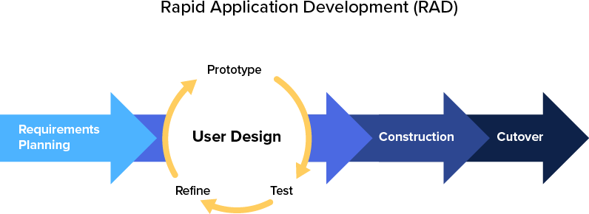The researchers use a development strategy called Rapid Application Development (RAD) which puts an emphasis on immediate feedback and rapid prototyping over lengthy development and testing cycles. This ensures a quality and client-focused end product. Rapid Application Development or RAD means an adaptive software development model based on prototyping and quick feedback with less emphasis on specific planning. In general, the RAD approach prioritizes development and building a prototype, rather than planning. With rapid application development, developers can quickly make multiple iterations and updates to the software without starting from scratch. This helps ensure that the final outcome is more quality-focused and aligns with the end users’ requirements (KissFlow, 2022). Figure 3 shows the RAD (Rapid Application Development)

Adopted from KissFlow (2022), [https://kissflow.com/application-development/rad/rapid-](https://kissflow.com/application-development/rad/rapid-application-development/) [application-development/](https://kissflow.com/application-development/rad/rapid-application-development/)

Figure 3. RAD Development Model

### **Requirements Planning**

The researchers and client cooperated in identifying and documenting the critical requirements for the emergency response system. This collaborative effort ensured that the development process aligns with the specific needs and objectives of the local emergency response ecosystem.

### **User Design**

The researcher developed the user design through numerous iterations. Customers are shown iterations of the system to make sure their needs are met. Developers work quickly to produce prototypes with a variety of features and functions rather than adhering to a strict set of specifications. These prototypes are then presented to BISARU for them to determine their preferences and dislikes.

### **Construction**

Since the majority of the issues and changes were addressed during the thorough iterative design phase, the researchers can now construct the final iteration of a module or the system itself. This phase is broken down into several steps: preparation for rapid construction, program and application development, coding, unit, integration, and system testing.

### **Cutover**

This is where the finished product goes to launch. BISARU and its crew can now use the newly released application. Data conversion, final tests and training will proceed right after. Still, the researchers and the client continue to look for bugs and problems that immediately needs addressing until finalization will complete.

### **Software Development Tools**

The following are the tools used in the development of Bilar Emergency Response Application using Dynamic Clustering Protocol of Bohol Search and Rescue Unit (BISARU) in Bilar, Bohol.

1. **Android Smartphone (API 21)** – The mobile device will be the main source of communication between the requestor and the responder. It is used to set up and use the **Emergency SOS** feature, which can help you call for help, share your location with your emergency contacts, and record video in an emergency situation. Also, this device will instantiate communication to the Firebase server via API key.
2. **Google Chrome (v111.0.5563.8)** - Emergency response application may vary and can be used as mobile or web-based. Chrome can be used as the browser to access and interact with these systems, allowing emergency responders to input and retrieve real-time information on incidents, resources, and personnel. Also, the device is used to debug, test and profile the management-side web app.
3. **Visual Studio Code (v1.75)** – Visual Studio supports web and mobile development, it allows us to create responsive and cross-platform applications. Develop web-based dashboards for real-time monitoring or mobile apps that can be used by responders in the field. It is the IDE used by the researchers to develop Bilar Emergency Response Application.
4. **Flutter (SDK 3.3.5) –** An open-source, cross-platform Software Development Kit framework used by the researchers to develop the application. Flutter supports offline functionality, allowing the application to continue functioning even when an internet connection is unavailable. This is crucial for emergency response scenarios where network connectivity may be unreliable.
5. **Dart (SDK 2.18.2) –** The programming language used in Flutter framework in developing cross-platform applications. Dart is used to support asynchronous programming, which is crucial for handling tasks such as fetching real-time data, making API calls, and processing background tasks.
6. **Git (v2.93.1) –** A DevOps tool used for source code management. It is used to track changes in the source code and allow multiple developers to work together. It allows non-linear development through branching. This is used by the researchers to manage the source code, collaborate effectively, and ensure a robust and organized development process.
7. **Firebase (v12.7.0) –** A Google-backed *BaaS* (Backend as a Service) application. The chosen backend service by the researchers. Firebase provides tools for tracking analytics, reporting, app crashes and creating market and product experiments.

### **Environment and Participants**

The study was conducted at BISARU located in the municipality of Bilar, Bohol. It has an estimated of 5-10 emergencies per month and working forces which consist of paramedics, emergency medical technicians (EMTs) and staff.

The participants of the study included the staff, paramedics and emergency medical technicians (EMTs). They gave their thoughts by rating the application usability questionnaires. BISARU provided us with the data and helped the development of the system successful.

### **Data Collection**

A letter of permission was put together to show support and make sure that the proposed system would be tested and put into use. Before starting to build the application, we talked to the staff and owner to find out what exactly was needed and what was missing. This helped us understand how the Business Information System Application Requirements and Understanding (BISARU) workflows work, which became the foundation for setting the necessary standards and requirements for the application.

Additionally, we took a practical approach, which involved watching how things are done and closely looking at the forms and reports that are currently being used. We did this to make sure we could easily include these existing elements in the design of the proposed graphical user interface (GUI) forms.

The application modules were derived from the events and scenarios outlined in the existing BISARU procedures. To assess whether the developed system fulfills the requirements of end-users, a system usability survey was administered. The study's participants included 15 individuals, consisting of one (1) paramedic, one (1) EMT, one (1) staff member, and 13 clients. Table 1 presents the breakdown of the respondents participating in the system usability assessment.

|  |  |
| --- | --- |
| **Respondents** | **Frequency** |
| Bilar Search and Rescue Unit Paramedic Bilar Search and Rescue Unit EMT  Bilar Search and Rescue Unit Staff  Bilar Search and Rescue Unit End-Users | 1  1  1  12 |
| **Total** | **15** |

**Table 1. Distribution of System Usability Respondents**

Table 2 shows the interpretation of the results used for system usability. The rating was done based on the System Usability Guidelines developed by MIT (Massachusetts Institute of Technology) Information Services Technology.

### **Table 2. Interpretation Guide of the System Usability**

|  |  |  |  |
| --- | --- | --- | --- |
| **Weight** | **Range** | **Description** | **Interpretation** |
| 5 | 4.6 – 5.0 | Strong Agree | The respondents strongly believe and confident that the  system is very usable. |
| 4 | 3.7 – 4.5 | Tend to Agree | The respondents tend to believe that the system is  usable. |
| 3 | 2.8 – 3.6 | Neither Agree nor  Disagree | The respondents are neutral in  trusting that the system usable. |
| 2 | 1.9 -2.7 | Tend to Disagree | The respondents tend not to  trust that the system is usable. |
| 1 | 1.0 – 1.8 | Strongly Disagree | The respondents strongly believe that the system is not  usable. |

To determine the acceptability of the system, the weighted mean score was computed to evaluate the system usability level the following formula:

**1 f 1 + 2 f 2 + 3 f 3 +**

**WMS 4 f 4 + 5 f 5**

**n**

Where: =

WMS = Weighted Mean Score

f1 = frequency of respondents who give a rate of 1

f2 = frequency of respondents who give a rate of 2

f3 = frequency of respondents who give a rate of 3

f4 = frequency of respondents who give a rate of 4

f5 = frequency of respondents who give a rate of 5 n = number of respondents

1,2…5= constant(rating)

**OPERATIONAL DEFINITION OF TERMS**

The terminologies and acronyms used or mentioned in this study and were further defined operationally in this study:

1. BERA – is the name of the software application means Bilar Emergency Response Application
2. BISARU – is the name of the government agency in Bilar, Bohol, Philippines, specifically the Bilar Search and Rescue Unit.
3. SMS – short message service
4. GPS – stands for Global Positioning System. It is a satellite-based navigation system that allows users to determine their approximate location (latitude, longitude, and altitude) anywhere on Earth.
5. EN – Emergency Notification
6. DSR – Design Science Research is a research paradigm that focuses on the development and evaluation of artifacts, such as systems, models, designs, or methodologies, to address complex problems.
7. SLR - stands for "Systematic Literature Review." It is a research method used to systematically identify, evaluate, and interpret all available research relevant to a particular research question, topic area, or phenomenon of interest.
8. VOS viewer - is a software tool used for constructing and visualizing bibliometric networks.
9. ET - stands for "Emerging Technologies refer to technologies that are newly developed or are in the process of becoming more widely adopted.

**Chapter II**

**PRESENTATION OF FINDINGS, ANALYSIS AND INTERPRETATION OF DATA**

**Existing Operation and Practices**

The Bilar Search and Rescue Unit (BISARU) operates around the clock to provide assistance with emergency concerns throughout the area of Bohol. BISARU continues to employ manual processes for the identification and location of emergency concerns. BISARU acknowledges the need for advancements and is actively exploring opportunities to integrate modern technologies for more efficient and effective emergency response.

**A. Receiving Emergency Through Communication Channels**

The traditional operational workflow of emergency response agencies involves a manual sequence of steps, beginning with the reception of emergency calls through various communication channels such as mobile phones, telephones, or frequency radios.

**B. Emergency Verification**

Upon receiving a distress call, the specialized response team promptly initiates a thorough verification process to confirm the authenticity and urgency of the reported incident.

**C. Deployment**

The response team promptly proceeds to the incident location, where they actively engage in the process of confirming essential details related to the accident,

carefully assessing factors such as its nature and impact, and ensuring accuracy in pinpointing the precise location of the incident.

**D. Generation of Reports.**

The generation of reports involves systematically documenting and recording pertinent details in a dedicated logbook, highlighting the ongoing need to refine and enhance the process for maintaining a comprehensive and organized record of relevant information.

These comprehensive verification steps are essential for ensuring accurate and effective emergency response. However, inherent delays are incurred in the overall emergency response due to the manual nature of these processes and the constraints imposed by travel time to reach the incident site promptly.

**Needs of the Existing Operation**

The present process will employ a cross-platform application-based approach, which can be customized to better suit user needs. The researcher’s observations led to the identification of the following needs:

1. To develop an app with communication and location tracking capabilities for users in need of assistance, ensuring that responders have accurate information about their situation. The goal is to enhance safety through effective communication and provide precise location details.

**BERA: BILAR EMERGENCY RESPONSE APPLICATION USING DYNAMIC CLUSTERING PROTOCOL**

After all the data and information that was gathered from the current system of BISARU Bohol and developed the “BILAR EMERGENCY RESPONSE APPLICATION”, a system that would handle emergency concerns more efficiently, optimize the verification process, and automate the generation of reports.

**A. Administration**

Authorized individuals are required to log in to access the system by entering their email and password in the login form. This security measure is implemented to prevent unauthorized access and potential breaches, safeguarding responder and user personal information from loss or compromise. Within the administration module, authorized personnel can adjust settings and oversee user roles.

**B. Emergency Notification and Dispatch**

The new system can generate alerts efficiently notifying designated responders. It provides details to ensure a well-informed response, and the system logs and tracks the entire alert and response process for comprehensive record-keeping and continuous improvement of emergency response procedures.

**C. Location Tracking**

The system can pinpoint the location of an incident through the use of geolocation technology. The location tracking feature allows for the quick identification of the exact site, facilitating timely assistance and intervention.

**D. Generation of Reports.**

The system will generate reports containing data on responders, including registered app users. This encompasses the utilization of graphical data visualization methods, such as daily, weekly, monthly, and annual incident reports. These reports may be formatted in tables, ready for convenient printing.

**Used Case Diagram**

According to Erikkson and Pemker (2000), a use case diagram illustrates the particular utilization of the system by one or more actors. The use case entails a series of actor or event steps, typically outlining the interactions between a role (referred to as an actor in the Unified Modeling Language) and a system to accomplish a goal. UML Use Case diagrams are commonly known as behavior diagrams and are employed to depict a set of actions (use cases) that a system or systems (subject) should or can execute in collaboration with one or more external users of the system (actors).

Figure 4 displays the use-case diagram of the BERA application, comprising the actors namely: emergency requestor, emergency message receiver, and emergency responder.

**Use Case Diagram**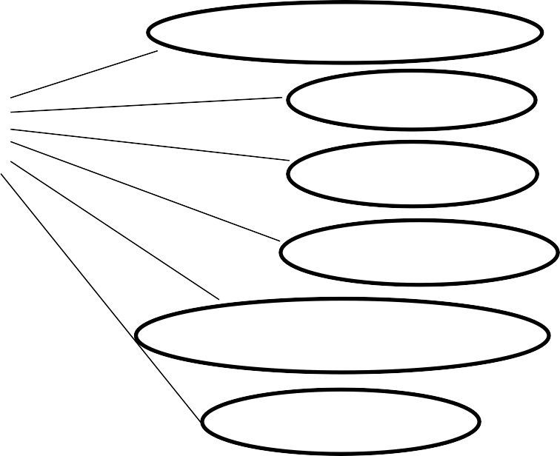

**Login With their Credentials**

**Edit Profile**

**Emergency Requestor**

**Send Photos for Evidence**

**Activate GPS**

**Receive Emergency Message**

**Receive Emergency Calls**

**Emergency Message Receiver**

**Access Google Map to track**

**the location of emergency requestor.**

**Track GPS location of the phone**

**Emergency Responder (Mobile Phone)**

**Capture Snapshots of the Scene**

**Send emergency message**

**Figure 4: Use Case Diagram of Bilar Emergency Response Application**

**Data Flow Diagram**

Admin/Responder

* Clients Identification
* Emergency Reports
* Rescue

Emergency Response System

* Call
* Request Help
* Clients Information
* Monitoring

Client

Admin

**Figure 5. Contextual Diagram of the Present System**

**Event Specifications:**

**Event list:**

1. Requesting Help Process
2. Recording of Requestor Data
3. Locating the Requestors
4. Generation of Reports

**Event List Diagram**

Figure 6 show the event diagram of inquiry process of the present system.

* Request
* Response

Request Help

Service

Client/Admin

**Figure 6. Request Help Process**

Figure 7 show the event diagram of the recording of requestor data of the present system.

* Calling and

asking for

information

through calls

Recording of Requestor Data

Collection of clients data

Client

**Figure 7. Recording Requestor Data**

Figure 8. show the event diagram of Locating the Requestors of the present system

* Asking Location through

calls

Service

Locating Requestors

Admin/Responder

**Figure 8. Locating the Requestors**

Figure 9 show the event diagram of the Generation of Reports of the present system.

* Recording of

Incidents in a

logbook

Report

Generation of Reports

Staff

**Figure 9. Generation of Reports**

**Use Case Narrative**

A use case narrative outlines a scenario that necessitates a comprehensive understanding of the use case framework, illustrating the interaction between the user (actor or use case) to attain a goal with observable value. It should encompass more than a basic sequence of user-to-system interactions, incorporating essential elements. Every use case narrative includes pre-conditions, processes, and post-conditions. Table 5 presents the use-case narrative for accessing the system by logging in.

**Table 3. Logging in (Emergency Requestor/Emergency Responder)**

|  |  |
| --- | --- |
| **Use case name** | Emergency Requestor/ Emergency Responder Log-In |
| **Actor** | Emergency Requestor/ Emergency Responder |
| **Precondition** | The app is installed on the user's device, and the requestor has a registered account. |
| **Description** | This use case describes the process of both users logging into the app to access emergency services. |
| **Typical Course of Action** | |
| **Actor Action** | **System Response** |
| **Step 1**  The user opens the app on their mobile device. | **Step 2**  Enters their registered username and password |
| **Step 3**  The app verifies the entered credentials. | **Step 4**  Upon successful authentication, the app grants access to the main dashboard for submitting emergencies and checking incident status. |
| **Alternate Paths**   * Unsuccessful Login: * If credentials are incorrect, the app prompts the user to re-enter. | |

Table 4 shows use case narrative for submitting an incident, outlining the user's interactions with the system.

**Table 4. Incident Submission**

|  |  |
| --- | --- |
| **Use case name** | Emergency Requestor Submits Incident |
| **Actor** | Emergency Requestor |
| **Precondition** | The requestor has already logged into the app. |
| **Description** | This use case outlines the process of an emergency requestor submitting details of an incident through the app. |
| **Typical Course of Action** | |
| **Actor Action** | **System Response** |
| **Step 1**  The app prompts the requestor to select what kind of assistance is needed (Police Emergency, Fire Emergency, or Health Emegency) | **Step 2**  The requestor presses the “Help” button to submit the details of the incident |
| **Step 3**  The app sends an instant notification to the admin and responders, alerting them about the submitted emergency. | . |
| **Alternate Paths**   * Incomplete Information:   If the requestor fails to provide necessary details, the app prompts them to complete the form.   * Confirmation:   The app may provide a confirmation message to the requestor upon successful submission. | |

Table 5 outlines the use-case narrative for signing up for user roles, explaining the step-by-step process for users to register and take on specific roles within the system**.**

**Table 5. Signing Up of User Roles - User Registration and Role Assignment (Responder/Requestor)**

|  |  |
| --- | --- |
| **Use case name** | User Registration and Role Assignment |
| **Actor** | New User (Emergency Responder or Requestor) |
| **Precondition** | The user has downloaded and installed the application. |
| **Description** | This use case illustrates the process a new user goes through when signing up for the application and selecting their role, either as an Emergency Responder or an Emergency Requestor. |
| **Typical Course of Action** | |
| **Actor Action** | **System Response** |
| **Step 1**  The user clicks on the "Sign Up" button and provides essential information such as name, email, phone number, valid Id, and password. | **Step 2**  After basic registration, the user is prompted to select their role:  Emergency Responder: Individuals interested in providing assistance during emergencies.  Emergency Requestor: Individuals who may need emergency assistance. |
| **Step 3**  Depending on the selected role, the user might be asked to provide additional information. For instance, an Emergency Responder may input skills or certifications, while an Emergency Requestor may input any relevant medical information. | **Step 4**  The admin reviews the provided information, confirms their role, and creates the user account with the provided details and assigns the chosen role. |
| **Alternate Paths**   * None | |

Table 6 shows the use-case narrative of a responder receiving an alert explains the series of actions and interactions between the system and the responder during the alert reception process.

**Table 6. Receiving Incident Notification and Dispatch – (Responder/Admin)**

|  |  |
| --- | --- |
| **Use case name** | Responder and Admin Receives Incident Notification |
| **Actor** | Responder/Admin |
| **Precondition** | The responder or administrator has logged into the application, installed it, or opened in a web environment. |
| **Description** | This use case illustrates the process a new user goes through when signing up for the application and selecting their role, either as an Emergency Responder or an Emergency Requestor. |
| **Typical Course of Action** | |
| **Actor Action** | **System Response** |
| **Step 1**  Both admin and responder receive an emergency notification. | **Step 2**  Clicks the notification and displays the profile of the patient and their location. |
| **Step 3**  The responder takes necessary actions, such as moving to the incident location. | **Step 4**  Responder take photos of the incident and send to the admin. |
| **Alternate Paths**   * None | |

Table 7 shows the use-case narrative for managing user accounts in the admin details the process of overseeing and controlling user accounts for both regular users and administrators.

**Table 7. Account Management – (Administrator)**

|  |  |
| --- | --- |
| **Use case name** | Admin Manages User Accounts |
| **Actor** | Admin |
| **Precondition** | The admin is logged into the admin portal of the application. |
| **Description** | This use case outlines the process when an admin manages user accounts within the system. |
| **Typical Course of Action** | |
| **Actor Action** | **System Response** |
| **Step 1**  The admin navigates to the user management section of the admin dashboard. | **Step 2**  The admin views a list of all registered users, including responders and requestors. |
| **Step 3**  The admin selects a specific user account for management. | **Step 4**  The admin selects a specific user account for management. |
| **Step 5**  After making modifications, the admin saves the changes to the user account. |  |
| **Alternate Paths**   * None | |

Table 8 use-case narrative illustrates the editing of profile information for both requestors and responders.

**Table 8 Editing of Profile Information (Requestor/Responder)**

|  |  |
| --- | --- |
| **Use case name** | Profile Editing |
| **Actor** | Requestor/Responder |
| **Precondition** | User is already logged in and in the account module |
| **Description** | Allow user to view, edit and update account |
| **Typical Course of Action** | |
| **Actor Action** | **System Response** |
| **Step 1**  User selects “Profile” tab | **Step 2**  Displays user info and list of action menu. |
| **Step 3**  User clicks the edit profile icon. | **Step 4**  Displays user info form and save button. |
| **Step 5**  Users fill in the form and click the save button. | **Step 6**  If the user clicks the save button, data stored in the database will be updated and displays a confirmation message.  **Go back to Step 4.** |
| **Alternate Paths**  Step 5   * If the form is not filled completely, A form invalidation label will display in each field. | |

Table 9 shows the use case narrative of logging out from the system.

**Table 9. Logging Out (All)**

|  |  |
| --- | --- |
| **Use case name** | Logging in |
| **Actor** | All |
| **Precondition** | Users are logged in |
| **Description** | Allow users to leave the system |
| **Typical Course of Action** | |
| **Actor Action** | **System Response** |
| **Step 1**  User clicks Profile tab. | **Step 2**  Displays user information with a list of actions. |
| **Step 3**  User presses Sign Out button | **Step 4**  The system will clear cached history of the previously signed in account and redirects to sign in screen. |
| **Alternate Paths**   * None | |

**Database Design**

Database design involves creating a data model for the database, encompassing the essential logical and physical design decisions as well as the storage parameters necessary to formulate a comprehensive data design. definition language, which can then be used to create a database.

System design is the procedure of specifying the components, modules, interfaces, and data for a system to meet the specified requirements of the Bilar Search and Rescue Unit. The researchers' objective is to develop a new system tailored for office use. In order to meet the client's needs, various improvements were made to BISARU' s existing infrastructure and operational processes.

**Class Diagram**

A class diagram in the Unified Modeling Language (UML) is a graphical representation that depicts the structure of a system. It provides an overview of the classes present in the system, their attributes, operations, and the relationships or interactions among them. It provides visual representation of the system’s structure and facilitate communication across stakeholders. Figure 8, refers to the instances depicting the most utmost processes of BERA.

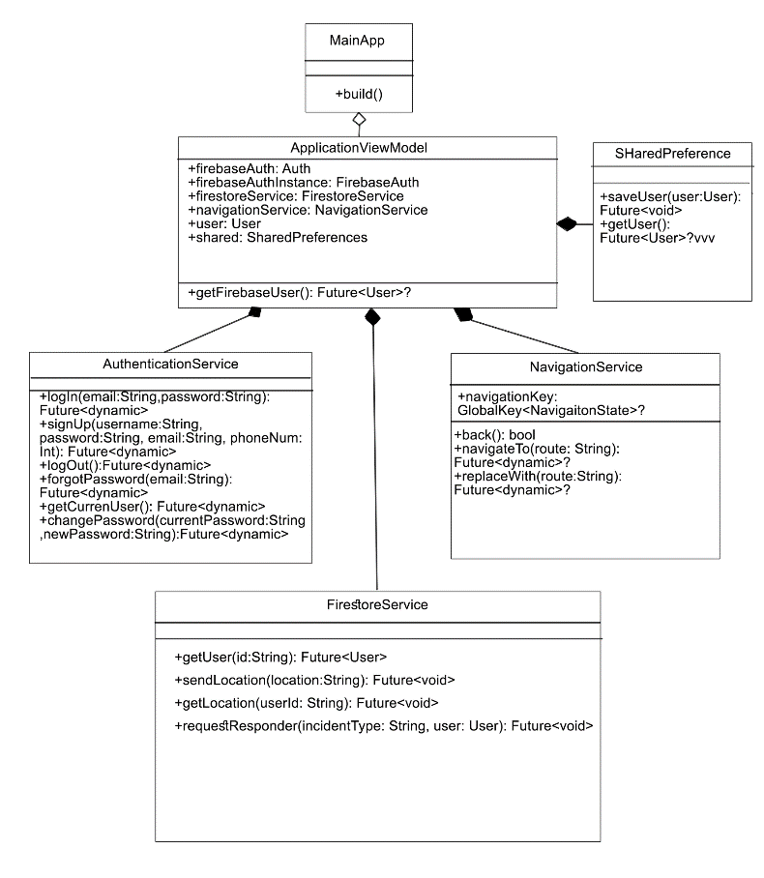

**Figure 8. Class Diagram of the BERA**

**Data Structure**

The following tables below were the database tables that were used in storing the information that was inputted in the system together with a collection of requirements that facilitate searching, sorting, and similar activities. It is a particular way of organizing data on a computer so that it can be used effectively. Table 10 shows the data structure for user account credential.

**Table 10. User Account Credential**

User Account Credential

|  |  |  |  |
| --- | --- | --- | --- |
| **Field No.** | **Field Name** | **Type** | **Description** |
| 1 | uid | String | User Id  Email |
| 2 | email | String |
| 3  4 | password  phone number | Hash  int | password  phone |

Table 21 shows the data structure for system users. It is organized in a way that is efficient to index and to retrieve.

**Table 11. System User**

User Information

|  |  |  |  |
| --- | --- | --- | --- |
| **Field No.** | **Field Name** | **Type** | **Description** |
| 1 | uid | String | User Id |
| 2 | firstname | String | First Name Middle Name |
| 3 | middlename | String |
| 4 | lastname | String | Last Name |
| 5 | email | String | Email |
| 6 | role | String | User Role |
| 7 | image | String | Image Uri |
| 8 | phoneNum | String | User Contact No. |

**Table 12. Incident Information**

Incident Information

|  |  |  |  |
| --- | --- | --- | --- |
| **Field No.** | **Field Name** | **Type** | **Description** |
| 1 | uid | String | User Id |
| 2 | incident | String | Type of Incident  location  Username |
| 3  4 | location  username | String  String |
| 5 | phoneNum | String | User Contact No. |

# Program Hierarchy

A program hierarchy is a diagram that displays the system's breakdown into its most basic, controllable layers. Each Module is symbolized as a box that holds the Module within. The high-level design or architecture of a computer program is described using a program hierarchy. Figure 12 show the program hierarchy of the BERA Application

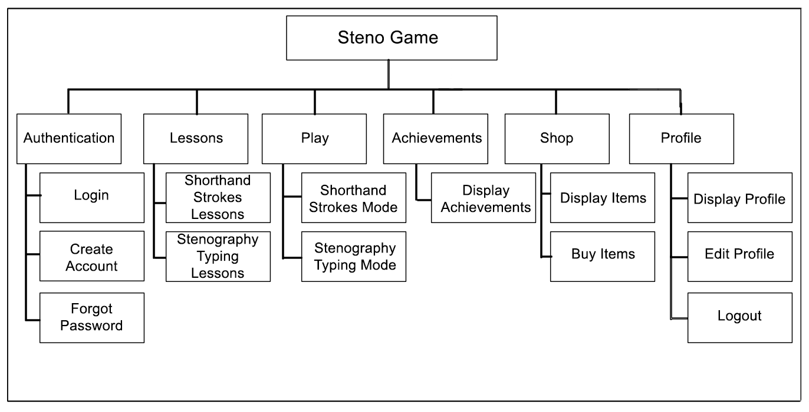

Settings

Record Daily, Weekly, and monthly incidents

Generate Reports

Reports

Add and Delete users

User Management

Respond to an incident

Locate the place of an incident

Location Tracking

Notifies Responders

Enable to send emergency notification

Emergency Send Notification

BERA Application

**Functional Requirements**

The function of a software system or component is specified by its functional requirements. Three components make up a function: inputs, behavior, and outputs. Functional requirements include processes like calculations, technical specifications, data processing and manipulation, and other particular functionality that outlines what a system is intended to do. A prototype was used to assist determine the functional requirements. A functioning prototype will be developed in close cooperation with the staff numbers of BISARU and a few of its clients in order to strategically identify functional requirements. Also, functionalities and modules will be based upon the existing standard operating procedures of Bohol Veterinary. The resulting functionalities are as follows:

**Process Log in**

FREQ 1: Access to the system should allow authorized Staff only to login

FREQ 2: The system should limit module accessibility corresponding to their access rules and privileges.

FREQ 3: All information gathered should be saved and secured

**Process Requestor Identification**

FREQ 4: The system should allow the recording of client’s information.

FREQ 5: All information gathered should be saved and secured

**Process Sending Incident Information**

FREQ 6: The system should send incident information.

FREQ 7: All information gathered should be validated by the admin

**Process of Location Tracking**

FREQ 8: The system should send location to the responders

FREQ 9: The system should identify the location of the incident.

**Generation of Reports**

FREQ 10: The system should allow the personnel in-charge to search, view and print reports.

FREQ 11: The system should allow the personnel in-charge to generate daily, weekly, monthly and annual sales in graphical ang tabular return.

**User Account Management**

FREQ 12: The system should automatically display save user account.

FREQ 13: The system should allow the personnel-in-charge to add client account.

FREQ 14: The system should allow its users to modify corresponding account. **Log out**

FREQ 15: The system should execute log-out process when invoked and should clear residual caches preventing data leak.

**Non-Functional Requirement**

A non-functional requirement specifies criteria that can be used to evaluate a system’s functioning rather than specific actions. Functional requirements, on 54 the other hand, describe specific behaviors or functions. The system design will include a plan for implementing functional requirements.

1. The system should be implemented with internet connection.

2. Classified modules must run on either browser or mobile device.

### **Technical Requirements**

Smartphones and computers have revolutionized industries, enabling efficient communication, streamlined operations, and enhanced productivity. From facilitating global business transactions to empowering educational institutions with online learning tools, these technologies have enabled innovation and driving progress across industries, businesses, government, and education.

To ensure effective operation, computer systems and mobile applications must carefully select the appropriate hardware and software components as well as the users who will be involved in system operation. When utilized appropriately, these parts will optimize performance and allow the system to reach its maximum potential.

The term "hardware" refers to the parts of the computer's CPU that are physically located; these parts include the CPU's lower casing, microprocessor, hard drive, RAM, UPS, monitor, mouse, and keyboard. The hard drive, RAM, and microprocessor are three of these parts that are essential for processing data and enabling efficient system operations.

The physical portion of the mobile phone is referred to as the hardware component. It has a display, speaker, microphone, battery, SIM card, USB port, memory unit, camera, Bluetooth/GPS capabilities, network connectivity, and more. However, the system-on-chip, also known as the CPU, and random-access memory, also known as RAM, were the only two components that assisted in data processing.

Computer applications are commonly referred to as software. However, the computer requires this set of instructions in order to process, store, and retrieve data. Software is another term for the programming language that the researcher will use to create the aforementioned system.

### **Minimum Hardware Specifications**

Table 29 shows the minimum android hardware specifications need by the system. This covers the minimum hardware requirements for the system to work as intended and expected. These specifications were chosen based on what is already available on the market and what most mobile phone systems provide.

### **Table 14. Minimum Android Hardware Specifications**

|  |  |
| --- | --- |
| **COMPONENT** | **SPECIFICATION** |
| CPU | DUAL CORE AND UP |
| RAM | 2 GB |
| ROM | 4GB |
| CONNECTIVITY | WIFI or LTE |

Table 30 shows the minimum desktop hardware specifications need by the system.

### **Table 15. Minimum Desktop Hardware Specifications**

|  |  |
| --- | --- |
| **COMPONENT** | **SPECIFICATION** |
| OS | WINDOWS, LINUX, MAC |
| RAM | 2 GB |
| CPU | INTEL CELERON, AMD A4 |

**Minimum Software Requirements**

Various software is needed for BERA to operate correctly. The minimal software specification can be found in Table 31. The Android units used to develop the system served as the foundation for the aforementioned specifications.

### **Table 16. Minimum Software Specifications**

|  |  |
| --- | --- |
| **COMPONENT** | **SPECIFICATION** |
| Operating System | Windows, Ubuntu Linux, Android |
| Windows Version | At least Windows 7 |
| Ubuntu Version | Ubuntu 22.10 (Kinetic Kudu) |
| Browser | Edge, Chrome, Safari, Firefox |

**Screen Layout**

The graphical user interface's design is explained by the screen layout. It should be separated from the graphical user interface's features and encompasses a range of applications where screens can be utilized in human-machine interaction. One of the many aspects of the system's user-friendliness is the screen layout. It should be made so that users can quickly and easily navigate the system and that the tasks they need to complete are clearly identified.

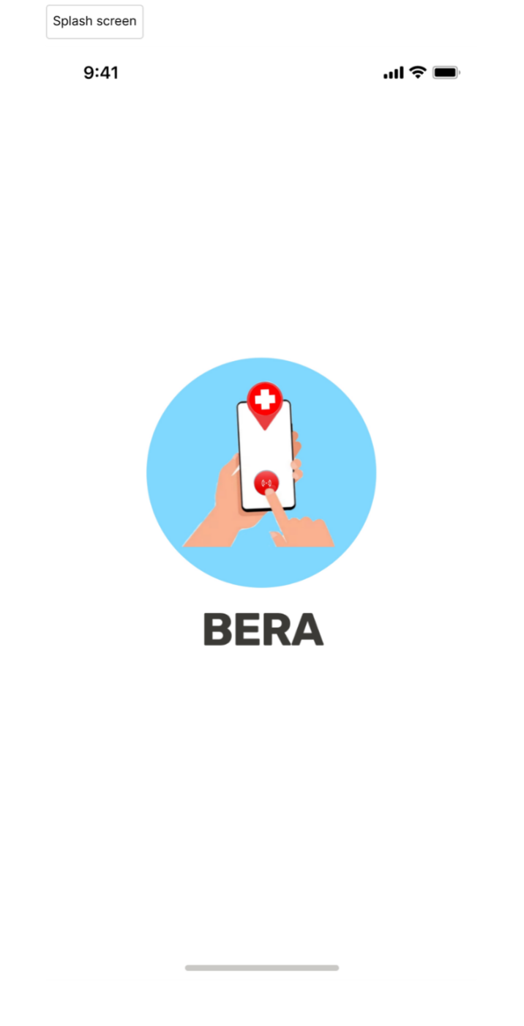

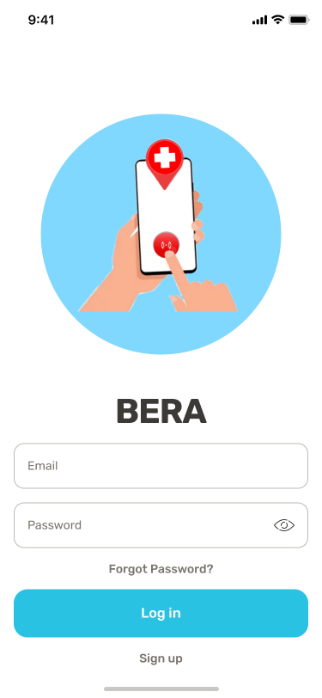

Preview 1: Splash Screen & Login Page

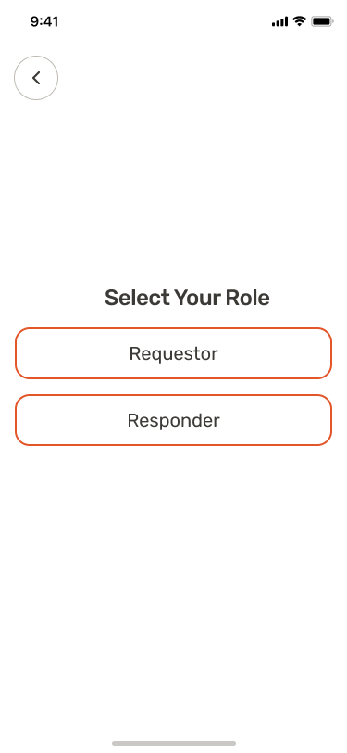

Preview 2: Role Selection

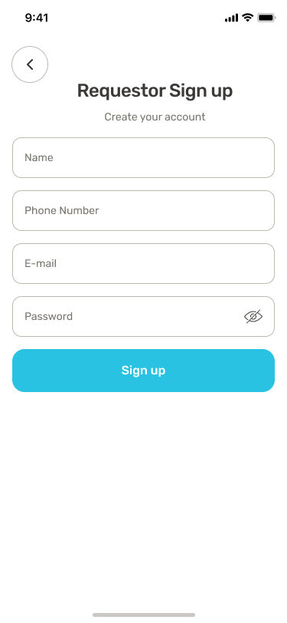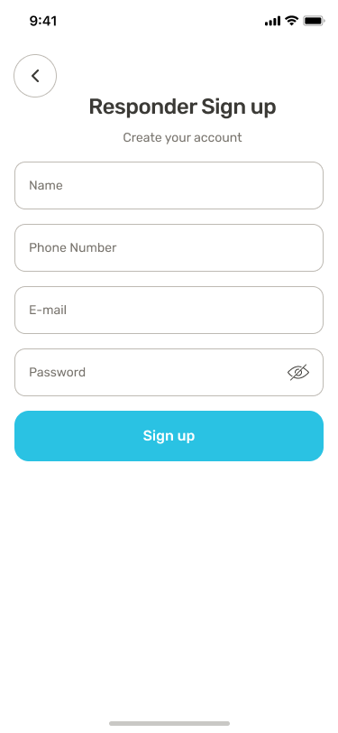

Preview 3: Sign Up Pages

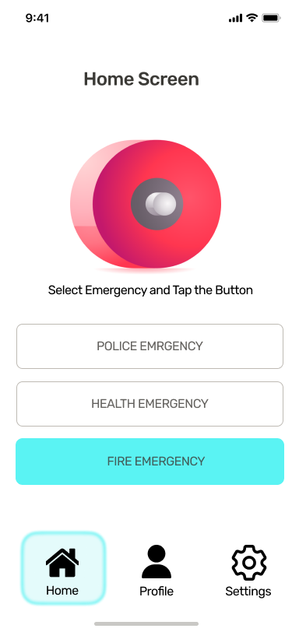

Preview: 4 Requestor Home Screen

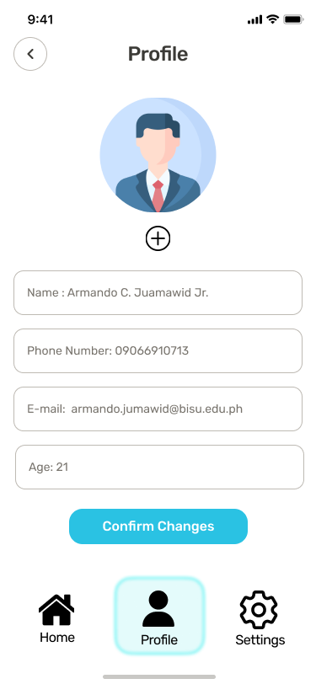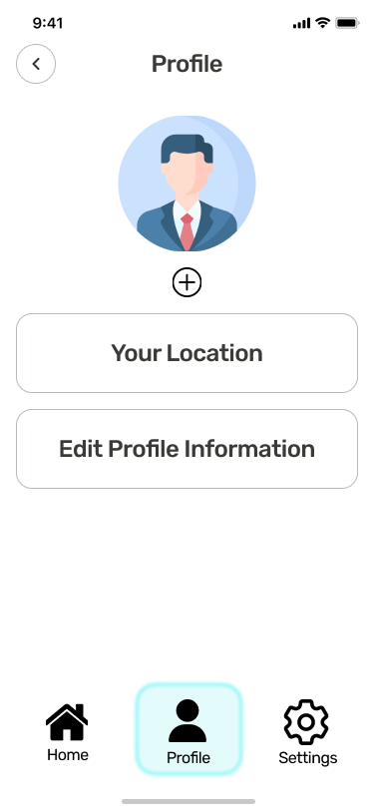

Preview 5: Requestor Profile & Edit Profile

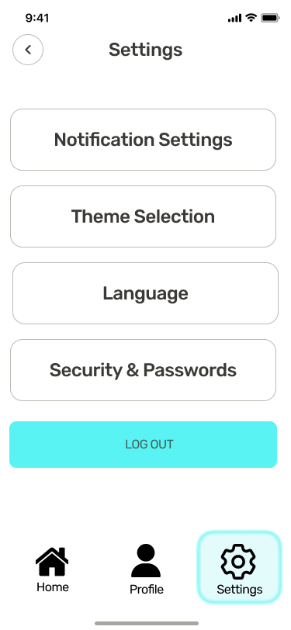

Preview 6: Settings

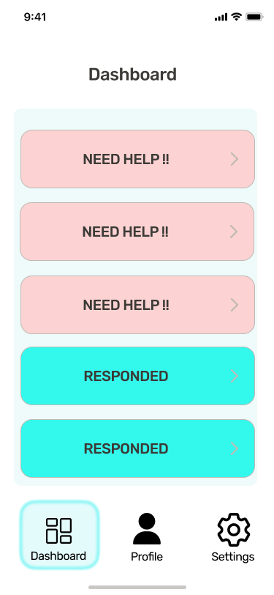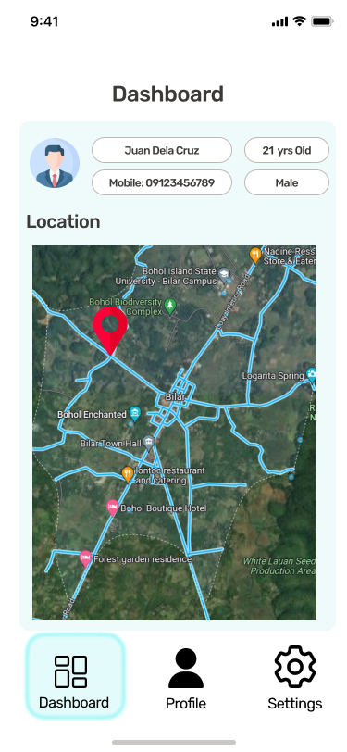

Preview 7: Responder Dashboard

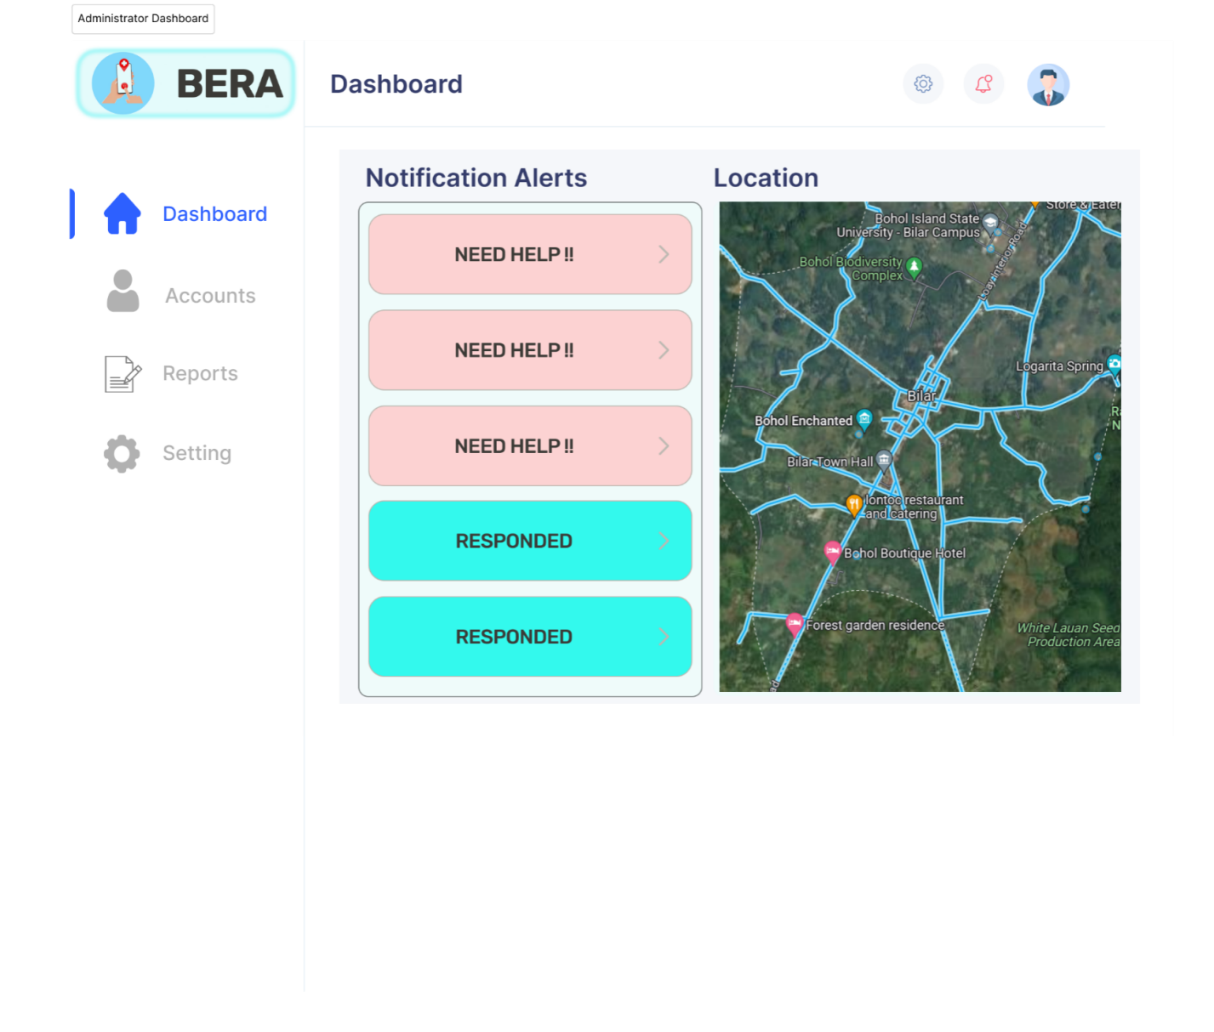Preview:8 Admin Dashboard

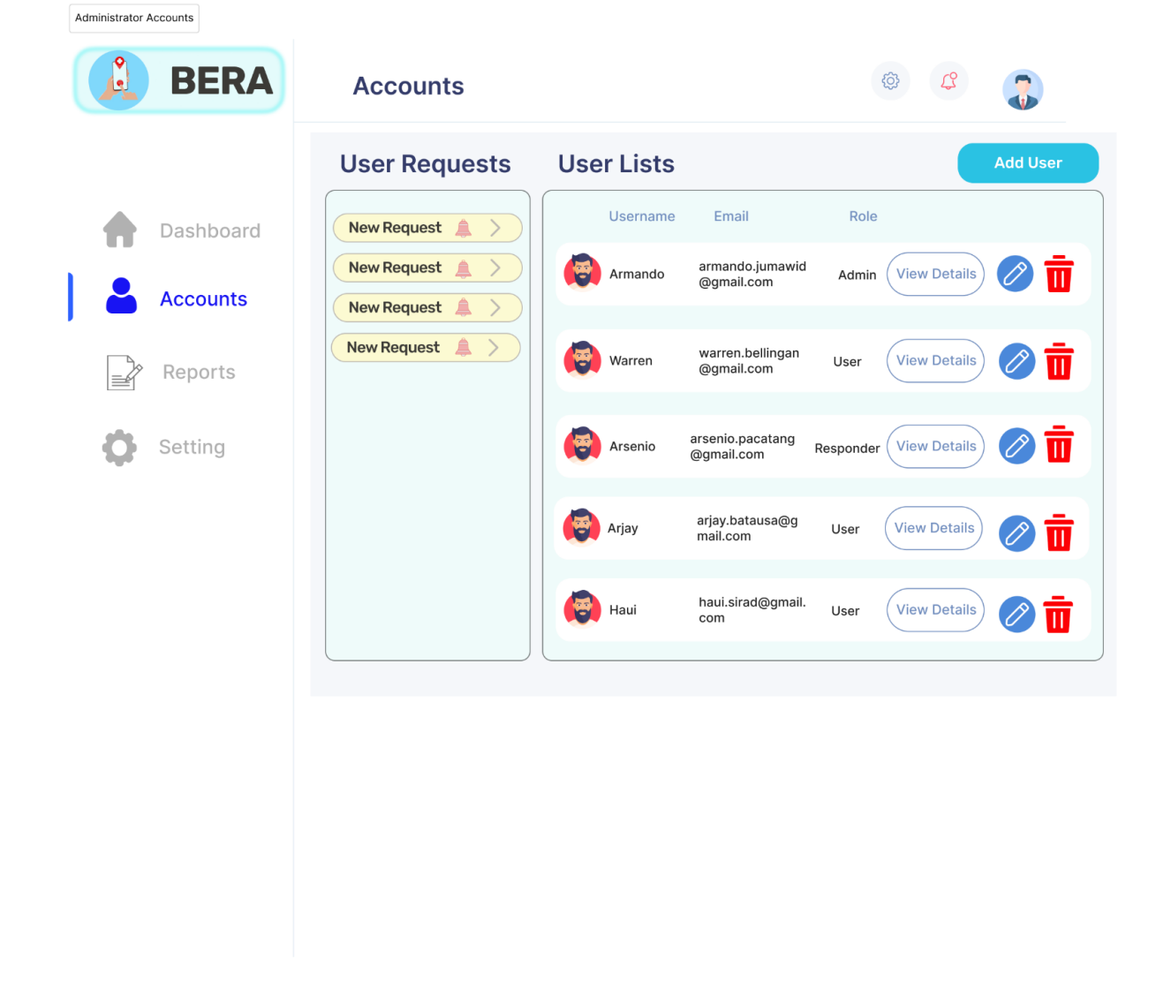

Preview: 9 Admin Accounts

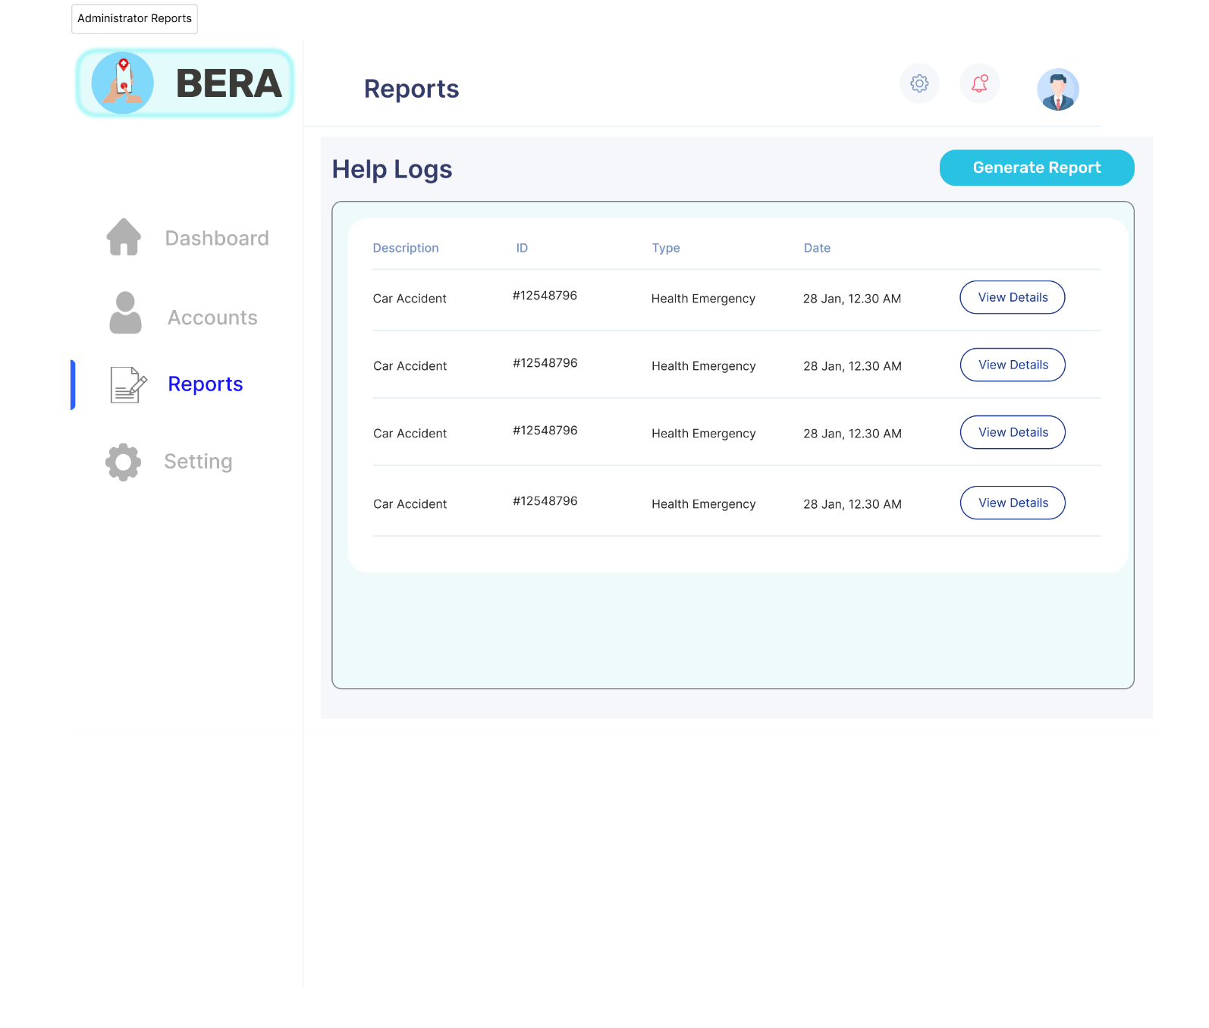

Preview: 10 Admin Reports

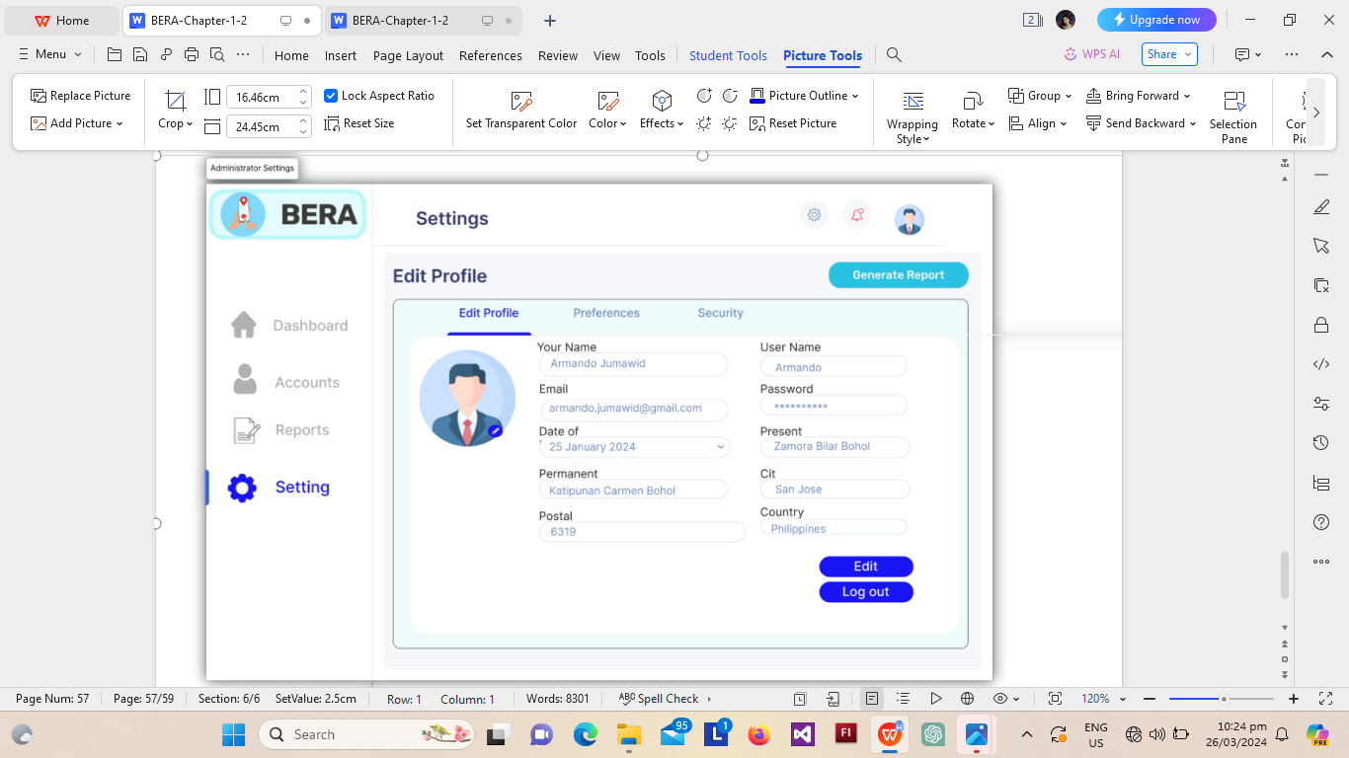

Preview: 11 Admin Settings

**REFERENCES**

Agrawal, S.A.; and Chavan, S.B. (2014). "EMS: An Android Application for Emergency Patients." *International Journal of Computer Science and Information Technologies (IJCSIT)*, 5(4), 5536-5538.

Aher, R.; Baviskar, P.; Chaudhari, P.; and Mahale, M. (2016). "Emergency Notification Services Application Design for Mobile Devices." *International Journal of Engineering Science and Computing*, 6(11), 3501-3502.

Bolle, S.; Hasould, P.; and Heuriksen, E. (2011). "Video Calls from Lay Bystanders to Dispatch Centres - Risk Assessment of Information Security." *BMC Health Services Research*, 11: 244, 1-7.

De Guzman, J.B.; De Guzman, R.C.C.; and Ado, R.G. (2014). "Mobile Emergency Response Application Using Geolocation for Command Centres." *International Journal of Computer and Communication Engineering*, 3(4), 235-238.

Drury, J., & Tekin Guven, S. (2020). "Emergencies and Disasters." In Together Apart:

The Psychology of COVID-19, 80-83.

Erkhembayar, R., Dickinson, E., Badarch, D., Narula, I., Warburton, D., Thomas, G. N., & Manaseki-Holland, S. (2020). "Early Policy Actions and Emergency Response to the COVID-19 Pandemic in Mongolia: Experiences and Challenges." The Lancet Global Health, 8(9), e1234-e1241.

Errikson E., Pemker M. (2000). Business Modeling with UML: Business Patterns at Work.

Fabito B.S.; Balahadia, F.F.; and Cabatlao, J.D.; (2016). "AppLERT: A Mobile Application for Incident and Disaster Notification for Metro Manila." *2016 IEEE Region 10 Symposium (TENSYMP)*. Bali, Indonesia, 288-292.

Hong, N.K.; Hafit, H.; Wahid, N.; Kasim, S.; and Yulof, M.M. (2017). "Help Me Please! Designing and Developing Application for Emergencies." *IOP Conference Series: Materials Science and Engineering*, 226 012116.

Ineya, S.S.; Ramya, R.; and Dinesh, P.S. (2017). "Emergency Reporting Using Smartphone." *International Journal of Computer Science Engineering*, 6(6), 140-144.

Jadhav, R.; Patel, J.; Jain, D.; and Phad-htare, S. (2014). "Emergency Management System Using Android Application." *International Journal of Advanced Research in Computer Engineering & Technology*, 5(3), 2803-2805.

Khan, Z. (2014). "An Emergency Alert SMS and GPS Tracking Application for Android Smart Phones." *International Journal of Advanced Research in Computer Science*, 5(3), 89-94.

Manoj, B. S., & Baker, A. H. (2007). "Communication Challenges in Emergency Response." Communications of the ACM, 50(3), 51-53.

Na, S., Xumin, L., & Yong, G. (2010, April). Research on k-means clustering algorithm: An improved k-means clustering algorithm. In 2010 Third International Symposium on intelligent information technology and security informatics (pp. 63-67). Ieee.

Pinheiro, A. S., Gouveia, R., Jesus, Â., Baptista, J. S., & Baptista, J. S. (2019). The importance of emergency response training: a case study. In *Studies in systems, decision and control*. https://doi.org/10.1007/978-3-030-14730-3_79

Ramirez, L.P.; Pondoyo, J.M; Laya, T.P.; and Bahio, N. (2013). "Sagip Pinoy: A Web and Mobile-Based Philippine Emergency Quick Response Portal." Retrieved October 1, 2021, from [link](https://docplayer.net/26227204-Sagippinoy-a- web-and-mobile-based-philippine-emergency-quick-response-portal.html).

Raut, D.B.; and Patil, P. (2015). "Research on Emergency Call and Location Tracking System with Enhanced Functionality for Android." *Internal Journal of Advance Research in Computer Science and Management Studies*, 3(5), 2321-7782.

Romano, M.; Onorati, T.; Aedo, I.; and Diaz, P. (2016). "Designing Mobile Applications for Emergency Response: Citizens Acting as Human Sensors." *Sensors*, 16(3), 406.

Steurer, K. M. (2018). Crime Around the World: Using Mathematical Modeling

Techniques to Model Aggregated Worldwide Crime Rates.

Whitzman, C., et al. (2013). Building Inclusive Cities Women's safety and the right to

the city, Routledge.

Xu, R., & Wunsch, D. (2005). Survey of clustering algorithms. IEEE Transactions on neural networks, 16(3), 645-678.

Xu, D., & Tian, Y. (2015). A comprehensive survey of clustering algorithms. Annals of

Data Science, 2, 165-193.

Zlatanova, S. and J. Li (2008). Geospatial Information Technology for Emergency Response

**DEVELOPER’S BIODATA**

**Name** : Ronelyn Garcia Perocho

**Place of Birth** : San Vicente, Pilar, Bohol

**Birthdate** : September 1, 2001

**Age** : 22

**Home Address** : San Vicente, Pilar, Bohol

**Email Address** : lyngarciaperocho@gmail.com

**Religion** : Iglesia Filipina Independiente (IFI)

**Citizenship** : Filipino

**Father’s Name** : Roman Galido Perocho

**Mother’s Name** : Liza Garcia Perocho

**EDUCATIONAL BACKGROUND**

**Elementary** : San Vicente, Elementary School

San Vicente, Pilar, Bohol

2013-2014

**Secondary**

**Junior High School :** Pilar Technical Vocational High School

Poblacion, Pilar, Bohol

2017-2018

**Senior High School :** Pilar Technical Vocational High School

Poblacion, Pilar, Bohol

2019-2020

**Tertiary** : Bohol Island State University

Zamora, Bilar, Bohol

2023-2024

**Degree Earned** : Bachelor of Science in Computer Science

Community-Based Computer Literacy Course

**Work Experience** : On-the-Job Training

Alturas Group of Companies

Poblacion, Talibon, Bohol

**DEVELOPER’S BIODATA**

**Name** : Mark Henry Cesar Perez

**Place of Birth** : Tagbilaran City

**Birthdate** : October 15, 1999

**Age** : 24

**Home Address** : Calvario, Loay, Bohol

**Email Address** : markhenryperez123@gmail.com

**Religion** : Roman Catholic

**Citizenship** : Filipino

**Father’s Name** : Edwin Perez

**Mother’s Name** : Camila Jane Perez

**EDUCATIONAL BACKGROUND**

**Elementary** : Senate President Protempore Jose A. Clarin Memorial School

Poblacion Ibabao, Loay, Bohol

2011-2012

**Secondary**

**Junior High School :** Camayaan, Loboc, National High School

Camayaan, Loboc, Bohol

2015-2016

**Senior High School :** Bohol Island State University

Zamora, Bilar, Bohol

2017-2018

**Tertiary** : Bohol Island State University

Zamora, Bilar, Bohol

2023-2024

**Degree Earned** : Bachelor of Science in Computer Science

Community-Based Computer Literacy Course

**Work Experience** : On-the-Job Training

Municipality of Batuan

Poblacion, Batuan, Bohol